**QR code in transportation**

Template

Version 1.0 ● 15 NOV 2011

Contents

Section 1. Project Overview 1

1.1 Project Description 1

1.2 Project Scope 1

1.3 Assumptions 1

1.4 Constraints 2

Section 2. Project Start-Up 3

2.1 Project Life Cycle 3

2.2 Methods, Tools, and Techniques 3

2.3 Estimation Methods and Estimates 3

2.5 Schedule Allocation 3

2.6 Resource Allocation 4

2.7 Budget Allocation 4

Section 3. Risk Management 5

Section 14. Appendices 6

**Online application(QR code in transportation )**

**Team name :**

Section 12

Abdelrahman mohamed ahmed

Abdelrahman abbas mohamed abbas

Abdelrahman fathy mohamed

Section 11

Abdelhakim omar abdelhakim

Section 17

Mohamed reda younes

# Section 1. Project Overview

## 1.1 Project Description

The idea of applying QR code in transportation expresses the ease of using financial transactions, limiting the use of paper money and limiting the spread of infection by touching it. It is a safer and more widely used idea in developed countries.

The user will be registered through application on online basis.

Objectives of the project will focus on implementing QR APP in transportation

Easy ticket process by opening the app from the mobile and make the phone read the QR code and select the money you will pay

Limiting theft of money: by paying from the app of the mobile

The project would be valuable to general society: the app will be available to all android app

Limit the Viral infection and Promiscuity the app will limit the Promiscuity by paying from the app not by money paper

The card will be available to everybody , any body can make the card in the bank

## 1.2 Project Scope

**Our projects includes some features :**

1. android app : we can install it on our any android mobile from play store
2. electronic payment : our project helps people to pay in the Transportation through app not cash to limit Promiscuity
3. location determination : our app Is offered determine the location that you is in it and you will go to it
4. selecting money screen :screen of money determination that the user will select how much he will pay depending on where he will go
5. scan QR code screen :screen that scanning the QR code that is existing in the bus , to pay
6. online app : the app wants internet connection
7. Screen to display the rest of your money in the bank : after you select the money you will pay there is a screen will appear of how much you have money

Any project have Pros and Cons

The project have some excludes :

1. Web: the project will be android app only
2. IOS: the project will be android app only
3. Cash payment : the buses which working by this app Will not allow the cash payment
4. Offline : app will work by internet only

## 1.3 Assumptions*.*

1. The app needs Certain programs like ( MYSQL, netbeans)
2. The app needs specific Programming Languages ) flutter , C++ , java ,database)
3. App will be available to any android mobile , in app store there is a introductory video will be exist before the user install the app
4. The app needs GPS
5. Making flow chart for developers

## 1.4 Constraints*.*

Time : the project will take 4 months if there is a Modification or any error wants more time it may lead to lose in money

Budget: the customer will select a specific budget the project must do on it , project may need more programmers or developers

Lose resources : if the company lose any resource that the project need ( programs , programmers , developers , fall in system or internet )

Quality : the customer Meditates a specific quality , less quality will make problems and lose in money

Team : defect in the project team (exit a member from team , Member does not have experience for his task , A member is late in delivering his task,.. )

# Section 2. Project Start-Up

## 2.1 Project Life Cycle

*The QR code will be scanned by passenger from the machine in the bus. Then automatically it will send amount from our wallet to machine account which is maintained by transport system. Then user will get message of travelling ticket.*

*•REGISTRATION MODULE :The user provides personal details accordingly then he provides route details and before that add the amount to wallet from bank. the client gives important details like name, make password, mail, telephone number and so forth through enrollment shape and gets enlisted with the vehicle transportation framework.*

*•USER LOGIN form: The principle page of the application is the client login page that used to get enrolled with the application. they can login by giving the username and password through the user login module*

*•BANK wallet MODULE : Once the login is finished it prompts the bank page in which we give the bank subtle elements like card number, name on the card, cv and so on.*

*•LOCATION MODULE : A user needs to choose the beginning and the endpoint and it will produce fare details for the journey. From that point onward, we need to utilize QR scanner for scanning.*

*•QR SCAN MODULE :at the end of adding the cash to the wallet. The traveller needs to choose from and to subtle elements of the journey then it creates the cost of travelling per head. At that point we can likewise choose the number of travellers to movement, it figures the aggregate sum and then scans the QR code of the machine.*

*VERIFICATION MODULE :The QR code generated will be verified by the conductor and the amount will be deducted from the wallet into conductor’s wallet and later to the transport corporation from the conductor and tickets collected by conductor will be tracked by admin of the transport corporation*⇒

## 2.2 Methods, Tools, and Techniques

* The QR code application requires a high-level programming language (Java) to get realize how the system will work
* there is a MySQL language to assign the app database
* Getting an IDE like NetBeans and MySQL and link them together
* Taking care of application GUI frame
* We also use flutter in our app
* Our app is work by GPS

## 2.3 Estimation Methods and Estimates

| **Estimation Methods and Estimates** | |
| --- | --- |
| Description | [ Best / Most Likely / Worst] |
| Effort in person-months or person-hours | We will pay by today. |
| Schedule in calendar months | 4 months |
| Budget in dollars | 30.000$ |
| Level of Uncertainty | 10% |

## 2.4 Schedule Allocation

*The goal of the project is limiting of Paper transactions by using purse connected with your bank account and android app to know transportation available, traffic line available from somewhere to anywhere, price every traffic line and time that will take every traffic line. To reach our goal design app is linked with bank purse than you pay by app scan.*

## Planning

1. *Planning:*

* *Determine the main goal.*
* *Determine input and output.*
* *Determine primary model to requirements. in terms of human resources and money.*
* *Make feasibility study. (to know Is the project gain or not &Are we cover the cost of requirements or not)*
* *Determine risks and alternative.*
* *Determine BPP*

|  |  |  |  |
| --- | --- | --- | --- |
| *Planning phase [1]:* | | | |
| *Activity Number:* | *Task name:* | *Duration:* | *Predecessors:* |
| *1* | *1-Determine the main goal, input and output.* | *1 Days* | *--------------------* |
| *2* | *2- Determine primary model to requirements.* | *1 Days* | *1* |
| *3* | *3-Do feasibility study.* | *2 Days* | *2* |
| *4* | *4-Divide number of people on every task.* | *1 Days* | *---------------------* |
| *5* | *5-Drew Gantt chart and Network diagram.* | *1 Days* | *1* |
| *6* | *6- Determine risks and alternative.* | *2 Days* | *3,2* |
| *Analysis phase [2]:* | | | |
| *7* | *1- Determine priorities requirements.* | *2 Day* | *2* |
| *8* | *2- Determine final model to requirements.* | *2 Day* | *7* |
| *9* | *3- Analysis to all risks and alternative.* | *1 Day* | *6* |
| *10* | *4-make interview and questions* | *1 Day* | *9* |
| *11* | *5- Drew data flow diagram.* | *1 Day* | *10* |
| *Design phase [3]:* | | | |
| *12* | *1- Design data base (DB).* | *14 Day* | *11* |
| *13* | *2-Desine user interface (screens of app).* | *11 Day* | *11,12* |
| *14* | *3-Connect between DB and screens of app.* | *15 Day* | *12,13* |
| *Implementation phase [4]:* | | | |
| *15* | *1-Coding.* | *21 Day* | *12,13,14* |
| *16* | *2-Testing app and DB.* | *8 Day* | *15* |
| *17* | *3-Training user on it.* | *6 Day* | *16* |

|  |  |  |  |
| --- | --- | --- | --- |
| *Planning phase [1]:* | | | |
| *Activity Number:* | *Task name:* | *Start date:* | *End date:* |
| *1* | *1-Determine the main goal, input and output.* | *10-5-2021* | *10-5-2021* |
| *2* | *2- Determine primary model to requirements.* | *11-5-2021* | *11-5-2021* |
| *3* | *3-Do feasibility study.* | *12-5-2021* | *13-5-2021* |
| *4* | *4-Divide number of people on every task.* | *14-5-2021* | *14-5-2021* |
| *5* | *5-Drew Gantt chart and Network diagram.* | *12-5-2021* | *12-5-2021* |
| *6* | *6- Determine risks and alternative.* | *14-5-2021* | *17-5-2021* |
| *Analysis phase [2]:* | | | |
| *7* | *1- Determine priorities requirements.* | *12-5-2021* | *13-5-2021* |
| *8* | *2- Determine final model to requirements.* | *14-5-2021* | *17-5-2021* |
| *9* | *3- Analysis to all risks and alternative.* | *18-5-2021* | *18-5-2021* |
| *10* | *4- make interview and questions.* | *19-5-2021* | *19-5-2021* |
| *11* | *5- Drew data flow diagram.* | *20-5-2021* | *20-5-2021* |
| *Design phase [3]:* | | | |
| *12* | *1- Design data base (DB).* | *21-5-2021* | *9-6-2021* |
| *13* | *2-Desine user interface (screens of app).* | *10-6-2021* | *24-6-2021* |
| *14* | *3-Connect between DB and screens of app.* | *25-6-2021* | *15-7-2021* |
| *Implementation phase [4]:* | | | |
| *15* | *1-Coding.* | *16-7-2021* | *13-8-2021* |
| *16* | *2-Testing app and DB.* | *16-8-2021* | *25-8-2021* |
| *17* | *3-Training user on it.* | *26-8-2021* | *2-9-2021* |

|  |  |  |
| --- | --- | --- |
| *Planning phase [1]:* | | |
| *Activity Number:* | *Task name:* | *Resource:* |
| *1* | *1-Determine the main goal, input and output.* | *Analyst* |
| *2* | *2- Determine primary model to requirements.* | *Project manager* |
| *3* | *3-Do feasibility study.* | *Project manager* |
| *4* | *4-Divide number of people on every task.* | *Analyst* |
| *5* | *5-Drew Gantt chart and Network diagram.* | *Project manager* |
| *6* | *6- Determine risks and alternative.* | *Analyst* |
| *Analysis phase [2]:* | | |
| *7* | *1- Determine priorities requirements.* | *Analyst* |
| *8* | *2- Determine final model to requirements.* | *Analyst & Project manager* |
| *9* | *3- Analysis to all risks and alternative.* | *Analyst & Project manager* |
| *10* | *4- make interview and questions.* | *Analyst & Project manager* |
| *11* | *4- Drew data flow diagram.* | *Analyst & Project manager* |
| *Design phase [3]:* | | |
| *12* | *1- Design data base (DB).* | *Database designer* |
| *13* | *2-Desine user interface (screens of app).* | *App designer* |
| *14* | *3-Connect between DB and screens of app.* | *App designer & Database designer* |
|  | *Implementation phase [4]:* | |
| *15* | *1-Coding.* | *App designer & Database designer* |
| *16* | *2-Testing app and DB.* | *Tester* |
| *17* | *3-Training user on it.* | *Trainer* |

### Gantt chart :

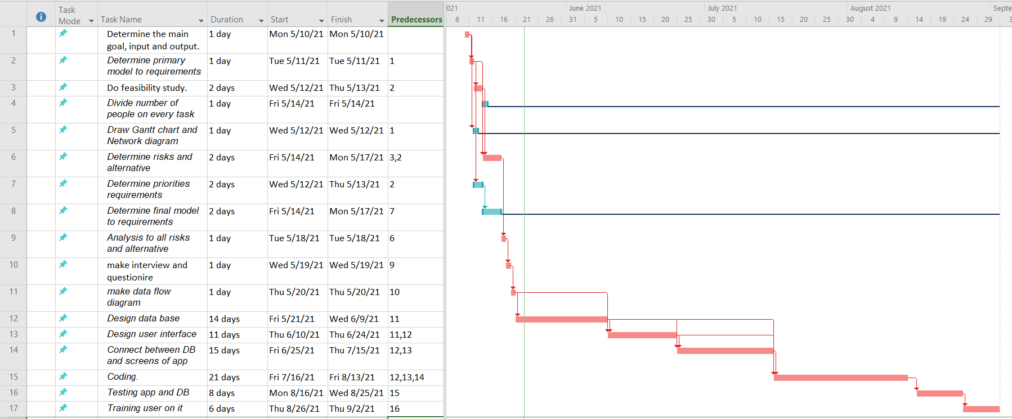

### network diagram :

Assuming money benefits of an information system at 35000$ per year, one-time costs of 30000$, recurring of15000$per year, a discount rate of 10%, and a 5 year time

|  |  |  |  |  |  |  |  |
| --- | --- | --- | --- | --- | --- | --- | --- |
| **Total** | **Year 5** | **Year 4** | **Year 3** | **Year 2** | **Year 1** | **Year 0** |  |
|  | $35000 | $35000 | $35000 | $35000 | $35000 | 0 | **Net economic benefit** |
|  | 0.6209 | 0.6830 | 0.7513 | 0.8264 | 0.9 | 1 | **Discount rate** |
|  | $21731.5 | $23905 | $26295.5 | $28924 | $31500 | 0 | **PV of benefit** |
| $132356 | $132356 | $110624.5 | $86719.5 | $60424 | $31500 | 0 | **NPV of all benefit** |
|  | | | | | | 30000 | **One time cost** |
|  | 15000$ | 15000$ | 15000$ | 15000$ | 15000$ | 0 | **Net economic cost** |
|  | 0.6209 | 0.6830 | 0.7513 | 0.8264 | 0.9 | 1 | **Discount rate (10%)** |
|  | $9313.5 | $10245 | $11269.5 | $12396 | $13500 | 0 | **PV of cost** |
| $86724 | $86724 | $77410.5 | $67165.5 | $55896 | $43500 | $30000 | **NPV of all costs** |
| $45632 |  | | | | | | **Overall NPV** |
| 0.52 |  |  |  |  |  |  | **Overall ROI** |
|  | 12418 | 13660 | 15026 | 16528 | 18000 | 0 | **Yearly PV cash flow** |
|  | 45632 | 33214 | 19554 | 4528 | 12000 | 30000 | **Yearly overall NPV cash flow** |

### Break even analysis :

Break even analysis = (yearly PV cash flow-Yearly overall NPV cash flow)/ Yearly PV cash flow

(16528-4528)/16528=1.726

Break-even point occurs at 1.726

NPV benefit

Cost

(BEA) 1.726 Years

## Analysis

* *Determine priorities requirements.*
* *Determine final model to requirements.*
* *Analysis to all risks and alternative.*
* *Draw context diagram*
* *Draw data flow diagram.*
* *Interview.*

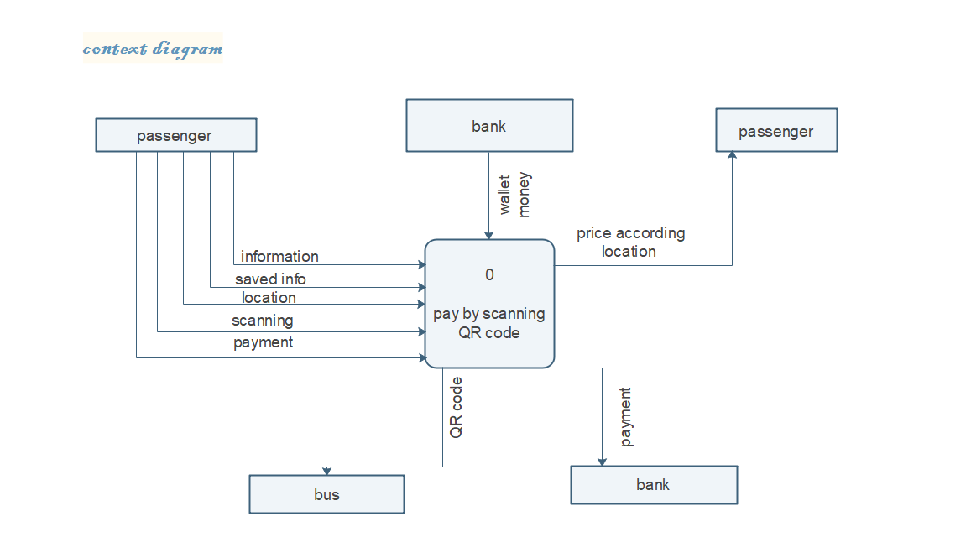

### Data Flow Diagram :

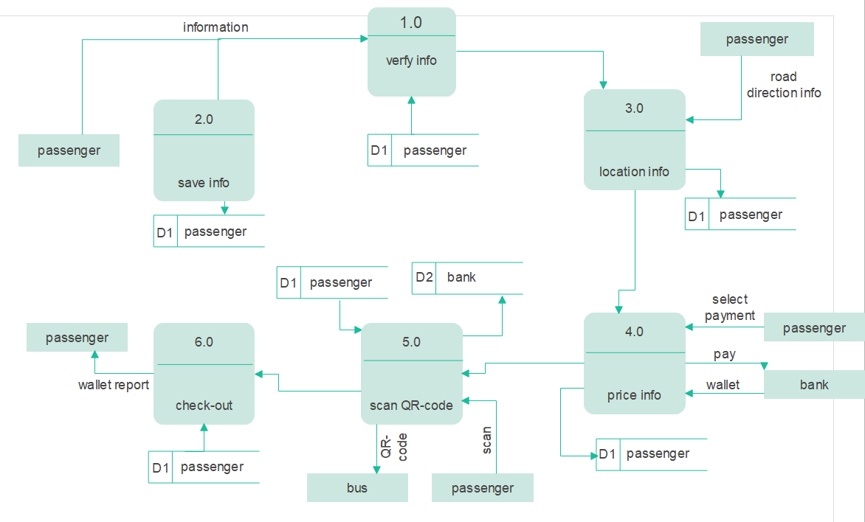

*The claims that the businessman wants to reduce financial transactions by making a bank wallet arranged in the program, the program makes a scan of the par code with it.*

*The passenger downloads the program and then logs in by filling in his personal data and the bank wallet ip. If it is the first time he logs in, a screen appears for him by making a bank wallet for him. After logging in and making a bank wallet for him, he enters the place that the passengers want from and the place he wants to go to, then shows the time it takes to arrive and the price for those who have a wallet and for those who do not have a wallet who wants to ride with someone who has a wallet that he wants to pay for and the time of available trips such as the trip he wants Go to it and he can tell all the routes using GPS. After he gets on the bus, he can use the GPS to know the remaining time to arrive, and when he reaches the place, he scans his electronic payment machine, and in this way we reduced paperwork and improved transportation.*

## Design

*3.1-data base (DB):*

* *Collect all elements (Entity) that care in project Such as:*
* *passenger.*
* *ticket.*
* *Bus.*
* *adminstrator.*
* *Trip.*
* *Driver.*
* *Determine properties to every element Such as passenger has properties like:*
* *passenger_ id.*
* *passenger_ name.*
* *passenger_ password.*
* *Passenger_ email.*
* *Passenger_phone.*

* *Determine relationships between element and some Such as:*
* *buy between passenger and ticket.*
* *has between ticket , bus and trip.*
* *has between bus and driver.*
* *Add between administrator and bus*
* *Determine a primary key to every element and foreigner key.*
* *Drew ER diagram and mapping.*
* *Create tables and link between tables and some.*

*______________________________________*

*3.2-Design screens of app Such as:*

* *login screen to login and make you purse.*
* *Code of purse screen to give you purse_ id special for you.*
* *List of way screen to choose way that you want, know way time, know way price for that has purse or has not purse and bus line from GPS.*
* *QR code screen to scan QR code to pay price.*

### ERD diagram :

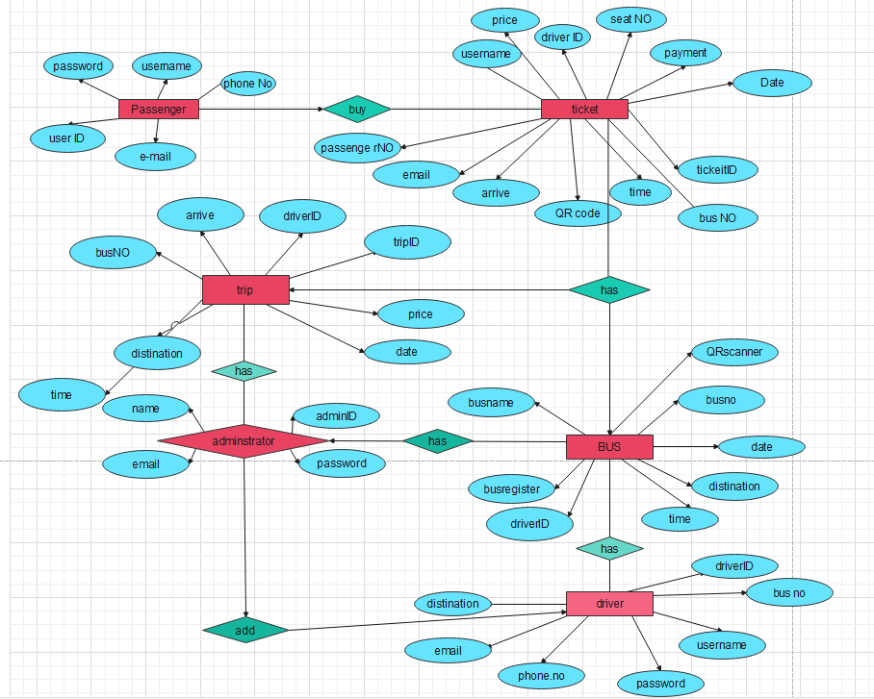

## 2.5 Resource Allocation

| **Resource** | **Total** | **Skill Set Requirements** | **Timeframe** |
| --- | --- | --- | --- |
| Project manger | 2 | Follow up on identifying user needs  He knows android skills | 3 |
| programmer | 4 | Dart java android flutter , My SQL | 20 |
| Database administrator | 4 | The ability to provide appropriate solutions to problems indenting errors | 15 |
| Technical | 3 | Has technical skills | 10 |
| Designers | 2 | Photoshop skills | 5 |
| My SQL | 5 | Version 10 | 10 |
| Analyst | 4 | Programming ,computer science ,management system | 15 |
| Tester | 2 |  | 3 |

## 2.6 Budget Allocation

|  |  |  |  |
| --- | --- | --- | --- |
| Activity Number: | Task name : | Budget Amount | Duration: |
| *1* | *1-Determine the main goal, input and output.* | *1000$* | *1 Days* |
| *2* | *2- Determine primary model to requirements.* | *1000$* | *1 Days* |
| *3* | *3-Do feasibility study.* | *1000$* | *2 Days* |
| *4* | *4-Divide number of people on every task.* | *1000$* | *1 Days* |
| *5* | *5-Drew Gantt chart and Network diagram.* | *1000$* | *1 Days* |
| *6* | *6- Determine risks and alternative.* | *1000$* | *2 Days* |
| *7* | *1- Determine priorities requirements.* | *1000$* | *2 Day* |
| *8* | *2- Determine final model to requirements.* | *1000$* | *2 Day* |
| *9* | *3- Analysis to all risks and alternative.* | *1000$* | *1 Day* |
| *10* | *4-make interview and questions* | *1000$* | *1 Day* |
| *11* | *5- Drew data flow diagram.* | *1000$* | *1 Day* |
| *12* | *1- Design data base (DB).* | *1000$* | *14 Day* |
| *13* | *2-Desine user interface (screens of app).* | *1000$* | *11 Day* |
| *14* | *3-Connect between DB and screens of app.* | *1000$* | *15 Day* |
| *15* | *1-Coding.* | *1000$* | *21 Day* |
| *16* | *2-Testing app and DB.* | *1000$* | *8 Day* |
| *17* | *3-Training user on it.* | *1000$* | *6 Day* |

# Section 3. Risk Management

|  |  |  |  |
| --- | --- | --- | --- |
| **Risk Description** | **Probability** | **Impact** | **Strategy** |
| *Cost Estimates Unrealistic* | Low | High | *We determine the cost of the project in addition to increasing a portion of the money to avoid any problem.* |
| *Time Estimates Unrealistic* | Low | High | *We set the right time to do the tasks required for the project.* |
| *Team Size* | Low | Low | *We choose a certain number of competent people to carry out the tasks required for the project.* |
| *Project Scope Creep* | Low | High | *Provide the project requirements tend to increase over a project lifecycle.* |
| *Team Members Unknowledgeable of Business* | Low | High | *We train people to make a tasks required for the project.* |
| *Available documentation* | Low | Low | *There is a copy of the documents with everyone in the group.* |
| *Narrow Knowledge Level of Users* | Low | Low | *We get everyone in the group to look for the project in different website.* |